

## Become a Certified theSource Wizard!

## Topic: Document Compare

Do you wish you could see exactly where in a document changes have occurred, such as updates and additions? You can by using the Document Compare feature! Document Compare takes the **Change History** information to the next level by pointing out exactly what was changed and where.

**How to use Document Compare:**

1. Upon viewing an updated document, click on the **Information** icon located at the bottom right side of the screen (next to the **Favorite Searches** icon).



**Result:** On the right-side, a window will display with two tabs: **Details** and **Change History**.

1. Click on the **Change History** tab.

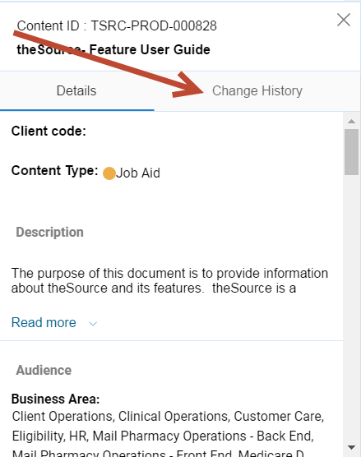

**Result:** The **Change History** will display a high-level description of what updates were made in the past versions of the document.

1. Click the **Compare to current version** button located in the last version information (directly below the current **Change History** entry).

* In the example shown below, version 11.0 is the current version and the **Compare to current version** can be found on Version 10.0 and the prior versions.

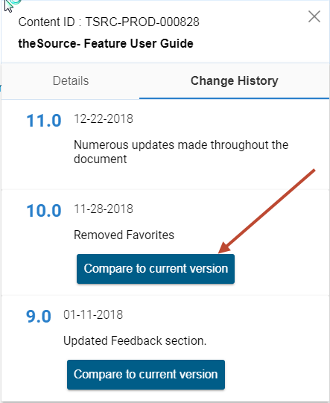

**Note:** All other previous versions contain the **Compare to current version** button as well, so you also can see the changes for any version available.

**Result:** The **Content - Compare Report** window will display showing all changes tracked. Additions are highlighted in green and deletions are highlighted in red.

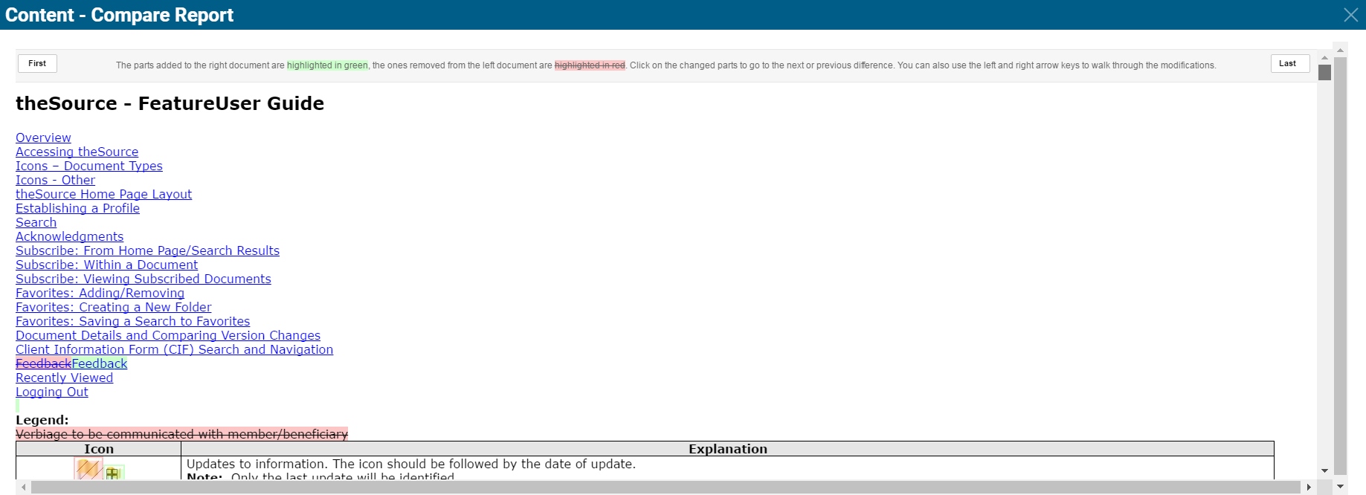

1. To walk through the changes, click on the first change and use the arrow buttons to navigate through the changes.

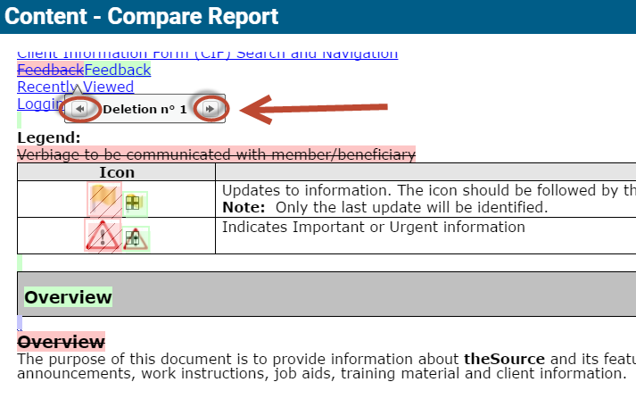

 Your next challenge on the quest to becoming a Certified theSource Wizard is to try out the Document Compare feature on each document you Acknowledge (if available).

Not to Be Reproduced or Disclosed to Others without Prior Written Approval

**ELECTRONIC DATA = OFFICIAL VERSION / PAPER COPY = INFORMATIONAL ONLY**